***“Using Technology in the Classroom”***

***Professional Development Session 3/18/14 - Ashley Pavao, Administrative Intern***



**Setting up account on GradeCam:**

1. Go to [www.mrspavao.weebly.com](http://www.mrspavao.weebly.com), “Professional Development”, click the link and create a free account.
2. Log in to GradeCam with your new account information.

**Creating Classes and Entering Student IDs**

*GradeCam can import student names and IDs from MMS, with a little tricky step in between.*

1. Go to your MMS Gradebook and open the “Student Roster”.

2. Then click “Print Roster”. Next, click “CSV (Comma Delimited)” in the drop down menu, then click “Export”. This will download the student data in a spreadsheet file called StudentRoster.xls.

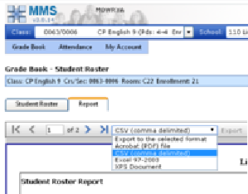

3. Open the downloaded file in Excel. *Delete all columns except first name, last name and student ID number and the top row with gibberish (see below)*. Then, save it as a new CSV file type. That is, click “Save as” then “Save as Type” then Save as type: “CSV (Comma Delimited)” and change the name to “StudentRoster.csv”.

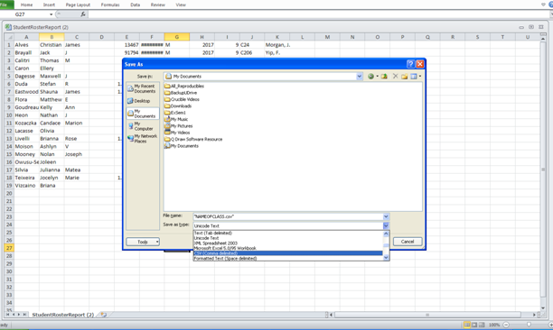

4. Open GradeCam and log in.

5. Click the “Classes” tab and then click the “Add Class” button.

6. Give the class a name and period, and then click “Done.”

7. Click “Import Students” and then import the CSV file you saved in step #3. Click “Import” and then “Next.”

8. Align the data to the correct slots by adjusting the columns. Your columns should read:

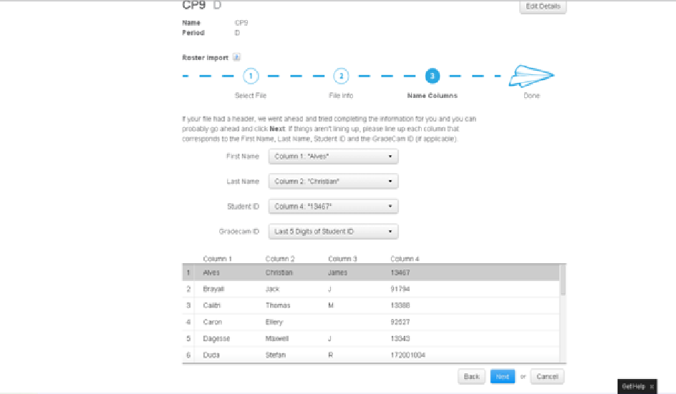

9. Click “Next” and “Submit” to finish importing. If necessary, you can also manually add or remove students.

**Creating an Assessment**

1. On the home page for GradeCam, click “Create”, name the assignment (keep it as “Exam”), then press “Done”.

2. Select the answers on the “Key”

3. Then, scan away!

**Printing a blank answer form**

1. Click the “Forms” tab at the top, and set it for the correct number of questions and for 5-digit ID numbers.

2. Print the form, and photocopy as necessary.

*Other features: With GradeCam you can also analyze the data under the “Reports” tab.*

**Set up of Elmo**

1. Go to <http://www.lincolnps.org/administration/technology-equipment-setup-2012> or my web page for more information.

2. You will need your HDMI cable to be plugged into your computer AND your elmo for it to work as a camera. You will know when it’s working if the TWO BLUE LIGHTS are illumined like in the picture below.

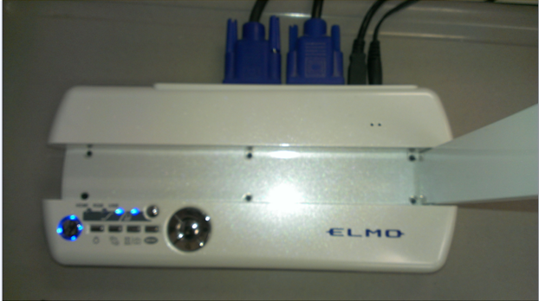

*Instructions updated and adapted from Tom Reeve’s presentation to the faculty, January, 2013.

How to (easily) build a website with **Weebly**!

1. Go to [www.weebly.com](http://www.weebly.com). Create a username, choose a password, and provide your e-mail address at which your students will be able to contact you.
2. Follow prompts and choose a theme and domain name (aka: website address)
3. Choose a title for your site.
4. Choose a layout for your page by dragging and dropping elements onto your page

**Suggested Elements:**

* 1. To add a document, scroll to *Media* and drag and drop the elements you wish to include
  2. To add pages, click the *Pages* tab, *New Page*, name it, and add desired elements.
  3. To create a blog, click the *Pages* tab, *New Blog*, name it and add desired elements.
     1. All students have to do to access and respond to the blog post is go to the website, click on the name of your blog page and then click *comment* on the top right of that page.

**Blog Management:**

1. Go back to the main page at [www.weebly.com](http://www.weebly.com) (that you will arrive at after you sign in).
2. Click *More🡪Blog Comments.*
3. Here you can read, approve and delete comments made in your blog.
   1. Side note: Here, you can also see *Stats* about your page (ex/ a graph about how many people have visited the site).

**Using Animoto**

1. Go to <http://animoto.com/education/classroom> and “apply” for a free account for educators. Use your school e-mail to sign up and it should immediately provide you with an access code. If this does not happen, you can still sign up for free. Follow the necessary steps to do this.
2. Once you’ve signed up, and signed in, click on the “Create” button in the top right hand corner of the screen. It will prompt you to choose a “Style”. Select one by clicking on “Create Video”.
3. Now, you’re able to begin creating. Depending on if your educator unlimited account application is approved, you may be limited to 30 SECOND VIDEOS so be selective about what you include in your video.
4. To add images or text, simply click on the “+” on a frame and add images or text. Images can also be added from Instagram, Facebook, and other programs.
5. Click on frames to edit them. Length of video shows up in right corner.
6. Remember to click “Save” periodically.
7. When you are ready to preview, click the lower left “Preview” button. If you want to accept the “Preview”, click “Produce”.
8. Once your video is finalized, there are a number of things you can do with it, like sharing it to Twitter, Facebook other social media sites, or you can link it onto your website.
9. For help, click “Help” on the bottom right.

**Suggestions for use in classroom:**

* Students could create a video showing character growth or analysis
* Students could take photos of their work and create an Animoto video to show how they have improved over time
* Students could interview a classmate as a “get to know you” activity and create a video introduction
* Students could explain a procedure or sequencing of events in a more engaging format
* *The options are endless! Any time you want to use pictures and text to explain something, an Animoto video could be used!*

**Using Storybird**

**SIGNING UP for Storybird:**

1. Go to **Storybird.com**
2. Click “Sign Up for Free” in the top right corner
3. Click “Teacher/Class”
4. Fill out username and password

**CREATING A CLASS**

1. You will then be prompted to create a class. Please fill out the information and “click submit”.
2. You will be asked to choose a picture for your avatar. You may skip this by clicking “skip this step” in the bottom right.
3. On the next screen, click on “Proceed as Free User” on the bottom right.
4. Click on “Add Students”.
5. If you have fewer than ten students, you can add them right here. If not, click on “Need More? Bulk Account Creation” on the bottom left. ***The free service will only let you add up to 35 students per account. You can sign up with more than one e-mail address to create new accounts.***
6. Option 1 will create a random list of usernames for you to assign to your students. Option 2 allows you to create the names yourself.
   1. I would suggest using Option 2 so you can avoid confusion when the class is signing in. I chose to make the usernames the students’ first and last names (Ex: JohnSmith). This made it easy to explain and for them to use.
   2. Using Option 2, type in the username, then a comma, then their first name, then a comma, then their last name. (JohnSmith, John, Smith). Press “enter” after each new username.
   3. If a username is already taken, just add “1” or another number at the end of it.
7. You will now see a list of your students and the temporary passwords that they were assigned. *Click “Print Student Login Cards.”* This will give you printable cards with their username and temporary password.

**CREATING AN ASSIGNMENT**

1. Click on “Assignments in the bar in the upper right.
2. Click “Create An Assignment”
3. Fill out the information and click “Save Assignment” when done.
   1. You must choose a piece of media to go along with the assignment. You may use a picture, video, or Storybird story.
   2. To use a story from Storybird you can browse the website for a story, and then copy and paste the URL
   3. For “Artwork” use “All Artwork” unless you know of a specific artist or tag (topic) that you want the kids to use

**CREATING A STORY:**

1. You may create a story or poem by completing an assignment or by clicking “Create” in the top left hand corner.
2. Choose any piece of artwork that you like. You may search for specific subjects by using the “Search Artwork Tags” in the left column. *You can’t add artwork from Google. What you see is what you get.*
3. Once you click on the artwork it will bring you to the author page. Underneath the main picture will be a row of smaller pictures with a “View All” square next to those.
4. Click on the “View All” square. This page shows you all of the artwork by this author. Make sure that these are the pictures that you want to use, and also that there are enough pictures for your task. *Note: When creating a story without a predetermined storyline, it is easier to let the pictures control the plot of the story than to try to select pictures to fit in a pre-determined storyline.*
5. **Once you’ve decided that you want to use it, click on “Use This Art” in the top right corner of the picture. Then click “For Story.” This will take you to the story maker.**
6. Drag any picture that you want to use onto the main rectangle. Pay attention to the lighter part of the picture. That is the part that will be white for you to put text.
7. Type your text. Then click the plus sign on the right side of the dark bottom bar. This will create a new page.
8. Repeat these steps until your story is complete. When you are done click on the title page, which is to the left of your other pages. Create your title page.
9. When done click “Menu” on the bottom left, and then “Save and Close” (you DO NOT have to publish it).

LOGGING OUT/GETTING HELP

1. You can log out or find the Help section by clicking on “You” in the top left corner.

**Suggestions for use in classroom:**

* Students could create a children’s book, synthesizing more complex information into a simpler form (i.e. simplifying the plot of *Lord of the Flies* into a 10 page children’s book).
* Students could create a story in the *style* of writing, literary movement, genre, etc. that they are learning about in class.
* Students could create a children’s book to demonstrate a lesson they have learned (in class or in life).
* Students could use this format to “tell the story of the future”, showing their career goals