Uploading a document to Richer Picture
- Go to www.lincolnlions.org
- Click on the link for “Richer Picture”
- Log in with your LAST NAME FIRST INITIAL, password= Student ID number or Lunch Code
- On the HOME screen, scroll down. You will see CP ENGLISH 9 and the assignment title
“On-Demand Persuasive Writing Common Task”- CLICK: “ADD”
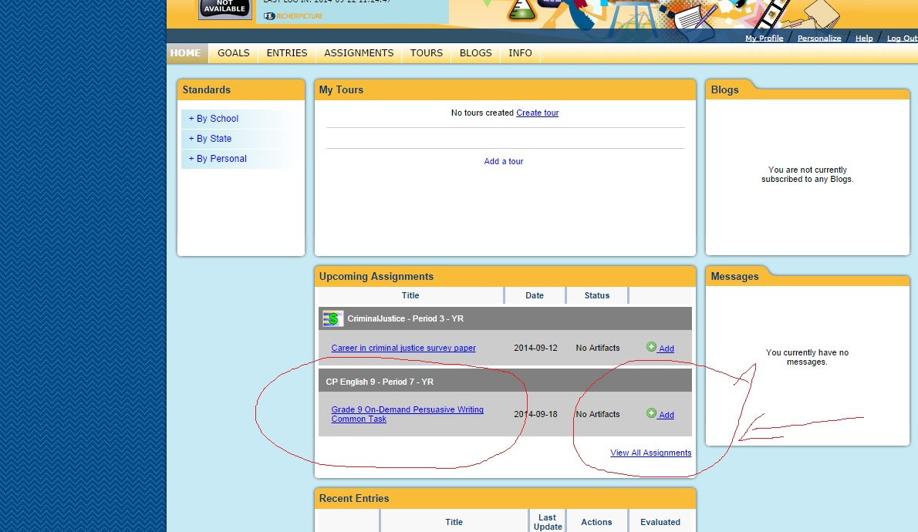

- Then, select “CHOOSE FILE” and find the file. Then Click “SAVE AND STAY ON THIS PAGE”
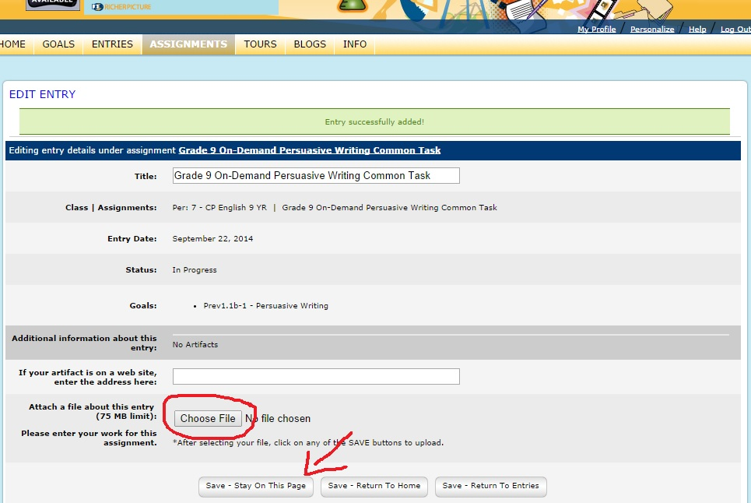
- When you see the document appear as a small box with the Microsoft Word icon, you know you’ve uploaded the document.
- Then, exit.

