Name: ________________________ Poetry Unit: Research Paper- Extended Essay
EXTENDED ESSAY PROMPT:
In a short research paper, explain how Langston Hughes used his poetry to inspire change in American culture.
OR explain how Langston Hughes’s poetry is a reflection of the culture during his time period.
Task Requirements:
Essay must CITE/reference at least 2 poems by Langston Hughes
Essay must ALSO CITE/reference at least 2 secondary sources
Essay should be 2-3 pages in length, typed, double-spaced, Times New Roman
MLA format must be followed AND Sources MUST be CITED in a WORKS CITED at the end of your paper
HELPFUL HINTS:
TEXTING in Research Papers
Body/Support Paragraphs: Follow each of the steps for each body paragraph.
- T for Topic: Tell what you are going to discuss in the paragraph
- E for Explain: Summarize the section you are going to analyze—provide context
- X for eXample: Provide the exact lines from the novel that illustrate the theme. Introduce the quote (using anchor) then be sure to cite the author’s last name and page number(s) after each quotation. Ex: “quote” (Twain 4).
- T for Theme & Transition: Discuss how the theme is shown in the quote.
- I for Introduce & Interpret what the critic is saying (make sure they support you!): Connect quotation from secondary source to your interpretation of theme and/or first example.
- N for Note the exact lines (QUOTE or paraphrase) from the secondary source (critic) that connects to your interpretation: Be sure to cite the author’s last name and the page number(s) after each quotation. Ex: (Bloom 123)
- G for Give a closure and transition: Tie all of your evidence to thesis then connect what you discuss in the current paragraph to what you will discuss in the next paragraph.

Paper Format:
- The first page of your paper should be in MLA format. See example:
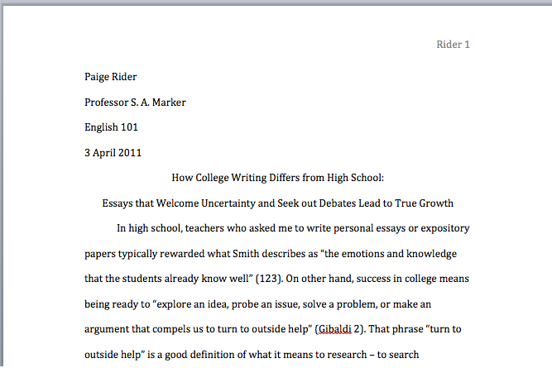
- After your essay, you MUST attach a Works Cited of ALL of the secondary sources you used. See below for example.
- Notice:
  - Sources are in ABC order
  - 2nd and 3rd lines are indented
  - Works Cited is simply formatted (NOT bold, NOT underlined, ETC).
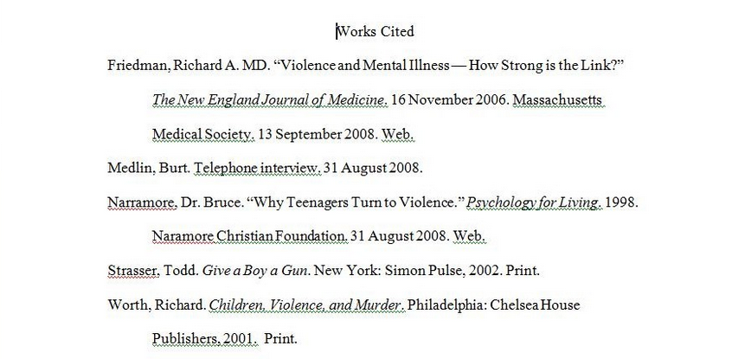
Citing Poetry in the Text of Your Paper (Parenthetical Documentation)
Quoting Three Lines or Fewer MLA 3.7.3, 6.4.8
When you are quoting three lines or fewer from a poem, you may incorporate the quotation into the body of your paragraph.
Tips for quoting up to three lines of poetry:
- Use slashes (/) to indicate line breaks within the poem
- Keep all punctuation intact as it appears in the poem
- Use quotation marks to denote the beginning and end of the quotation
If you have included the name of the poet elsewhere in your paper, do not include the poet's name in your parenthetical citation. Instead, include the first significant word of the poem's title, followed by the line number(s). This is especially important if you are quoting more than one poem by the same author in your paper.
Example
Eliot immediately engages the reader with his use of the second person in the opening lines: "Let us go then, you and I / When the evening is spread out against the sky" ("Prufrock" 1-2).
However, if you have mentioned the title of the poem in the sentences immediately preceding you quotation, you can cite the line number only.
Example
In his "The Love Song of J. Alfred Prufrock," Eliot immediately engages the reader with his use of the second person in the opening lines: "Let us go then, you and I / When the evening is spread out against the sky" (1-2).
Quoting Four or More Lines MLA 3.7.3
Tips for quoting four or more lines of poetry:
- Start the quotation on a new line.
- Indent each line one inch from the left margin of your paragraph.
- Preserve all punctuation, spacing, and line breaks exactly as they appear in the original text of the poem.
- Double-space between each line.
- Do not use quotation marks (unless they are used in the poem).
Example
Yeats, an Irish nationalist himself, knew several of the Easter Monday rebels personally, and he mentions them by name in his poem. He even notes his former nemesis, Major John MacBride. MacBride was briefly married to Yeats's love, Maude Gonne. Though he acknowledges MacBride's heroism, he does so begrudgingly:
A drunken, vainglorious lout
He had done most bitter wrong
To some who are near my heart
Yet I number him in the song; ("Easter" 31-34)

Poetry in the Works Cited List
The format of your citation will depend on the source of the poem. Poetry is usually published in one of the following sources:
- A literature or poetry anthology
- A collection of one author's poems
- As a single volume (for longer poems)
Tips for Citing Poetry:
- If the poetry is in an anthology, look at the title page to see if there is an editor.
- Always begin the citation with the poet, NOT the editor of the anthology.
- If you are citing several poems from the same anthology or collection, create a separate citation for each poem.
- Enclose the title of the poem in quotation marks unless the poem is published as a single volume.
-----------------------------------------------------------------------------------------------------------------------------------------------------------------------------
Poem in an Anthology or Collection MLA 5.5.6
Anthology, Poet and Editor
Most poetry is published as part of a larger collection of poems (and possibly prose works) called an anthology. Many anthologies have a volume editor in addition to to authors of the individual works; look on the title page to determine if the anthology has an editor.
Use the Example below to cite the poetry in our TEXTBOOK:

_________________________________________________________________________________________________________________________________________________________________________________________________________________________________________________________________________________________________________________________________
Example:
