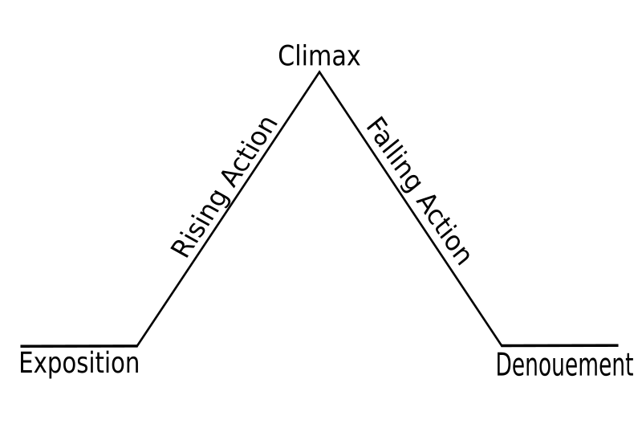

Conflict

Man vs. Man (trying to kill each other)

***The Sniper* Freytag’s pyramid**

**\*Use to study for midterms\***

**The setting:** Ireland during a Civil War

**Characters:** Republican sniper and Free Stater sniper

RESOLUTION: He turned over the dead man.

DENOUMENT: It was his brother!!!!!!

-He faked his own death by using a ruse (trick). He put his hat on the end of the gun and held it up so the enemy would shoot at it and think he killed him.

-He shot and killed his enemy, who fell to the streets below.

Turning Point: When he gets shot and has to figure out a way to escape before day break, this is the turning point/climax.

-He shoots and kills the informant and the enemy in the tank.

-He risked his life to light a cigarette and this caused him to get shot.



-We learn about their love story

-We learn that the princess is jealous of the lady

-We also learn that the princess has learned “the secret of the doors”

Conflict

-Man vs. self (deciding on the door)

-Man vs. society

-Man vs. nature (if tiger)

***The Lady or the Tiger* Freytag’s pyramid**

**\*Use to study for midterms\***

Setting: King’s arena, Medieval times

Characters: King, Princess and her lover

RESOLUTION: NOT RESOLVED!!! UP TO THE READER! Either dies or gets married.

DENOUMENT: Teaches us a lesson about *human nature*

-If the door has the tiger behind it:

He is eaten

-If door has lady: he gets married

The turning point is when the princess gestures to the door on the right.