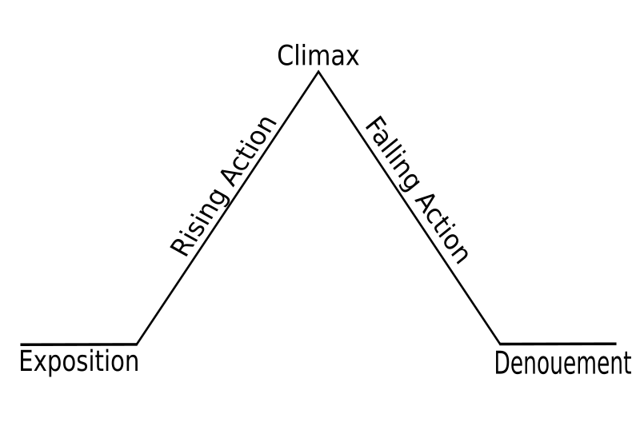

Setting: King’s arena, Medieval times

Characters: King, Princess, Lover

**Resolution: (unknown)**

Tiger: He dies

Lady: He Lives

**Denoument: About human**

If Tiger- The tiger attacks

If lady- The marriage begins

When the lover picks the door on the right, this is the turning point of the story.

-Princess finds out the “secret of the doors”

-We learn about Princess and her jealously and who the woman is behind the doors

-Princess gestures to the right

Conflict

Man vs. Self (questioning which door t pick), or Man vs. nature (if tiger comes out), Man vs. society