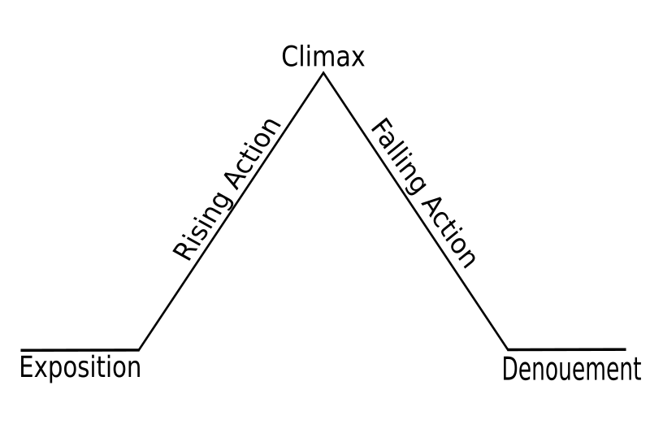

Setting- Dublin, Ireland in 1920s, during Civil War

Characters- Republican sniper is our Protagonist

Free Stater sniper is our antagonist

Resolution: The Republican sniper shot and killed the enemy sniper and was able to leave his rooftop.

Denoument: It was his brother!!!!

-Clean and bandage his wound

-Created a ruse (trick)- Faked his own death so that the enemy would “put his guard down”.

When the sniper gets shot by the enemy, this is the turning point of the story.

-Kills the informant and an enemy

-He drinks and smokes and smoking a cigarette caused his enemy to notice him and therefore, he was shot.

Conflict

Man vs. Man (civil war)