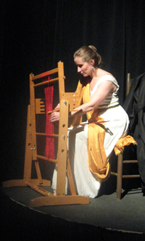
Name: ____________________________ The Odyssey Guide
“Penelope” (pgs 691-693) and “The Challenge” (pgs 694-696)
Directions: Answer each question while you read.
- Who is “the old beggar”?
- Why does he keep his identity a secret from his wife?

- In lines 1307-1308 and lines 1310-1311, Penelope says, “’Stranger, my looks, my face, my carriage, were soon lost or faded…If he returned, if he were here to care for me, I might be happily renowned!”

What do you think she means? What does “renowned” mean?

- In lines 1321-1327, Penelope explains her ruse that she used to put off marrying the suitors. What is her trick? Hint: A “shroud” is a covering used to cover dead bodies, and “Lord Laertes” is Odysseus.

- What did she do every night to keep her ruse going?

- After years of doing this, Penelope says lines 1339-1341. “Evade” must mean: ______________
- Therefore, Penelope is saying,

- Even after he learns that she still loves him, Odysseus still does not reveal his identity. Why?

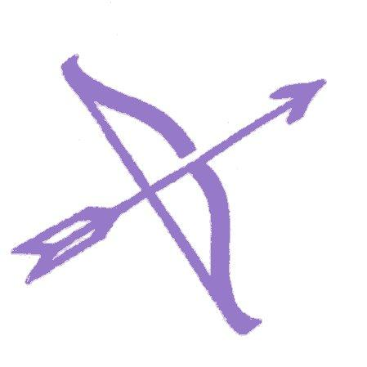
“The Challenge”
- Draw a picture in the space below of the “Challenge” Penelope presents to the suitors, described in italics.

- A simile is a comparison between two things using “like” or “as”. Explain the simile used to describe how Odysseus bends the bow.

- In lines 1389-1393, Odysseus lets the arrow go. What happens?

- Why does Telemachus “belt his sword on” at the end of the reading? What do you predict will happen next?

