Mythology and The Odyssey Review
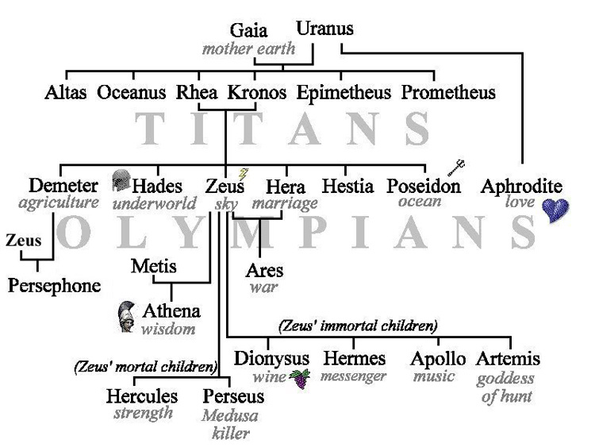
- Who was Hercules’s mortal enemy? Why?

- What did Hercules do and how was he punished?

- What is the name of the female that the Trojans and the Greeks fought over?

- How did man get fire from the gods?

- Who was Odysseus’s enemy? Why?

- Odysseus can be described as _____________ and his men are ______________.

- Who were Odysseus’s family members? Where did he live?

- What character trait was shown by his men in the Cinconians/Cinconies chapter?

- What did Odysseus learn in the “Land of the Dead”?

