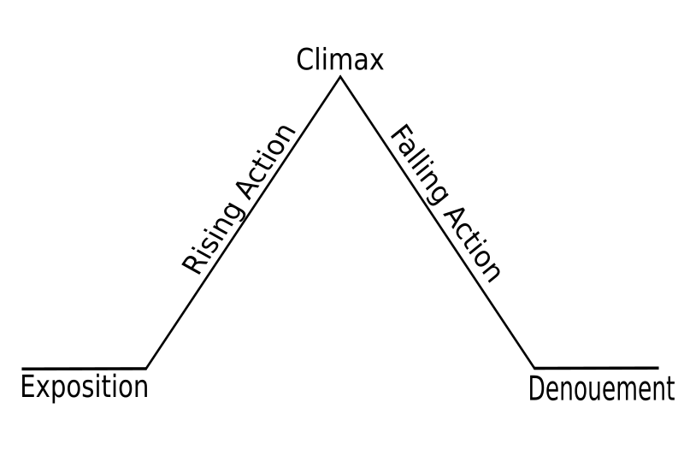

1. Rainsford falls off a boat and gets trapped on the island
2. Ivan holds a gun to his heart (very “welcoming”)
3. Zaroff meets R and they have dinner and discuss hunting.

**STUDY GUIDE FOR MIDTERM**

**Freytag’s pyramid of the “Most Dangerous Game”**

Setting: Ship Trap Island

Main Characters: Rainsford (protagonist), General Zaroff (antagonist)

RESOLUTION: Rainsford kills Zaroff

Denoument: Rainsford sleeps in Zaroff’s bed and we assume, goes freely back into the world.

1. R tries to get out of being hunted
2. 3 traps to try to catch Zaroff; he injures Z, kills the dog & kills Ivan
3. He fakes his death, sneaks into the chateau and waits to kill Zaroff.

Rainsford realizes he is going to be hunted

Conflict

Man vs. Man