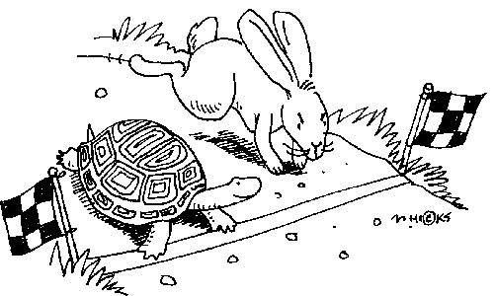LHS Field Hockey: Focus Points for the Season

1) Mantra: If we BELIEVE, we can ACHIEVE!

2) The 3 T’s:
Trust Talking Teamwork

3) This season’s FABLE FOCUS:
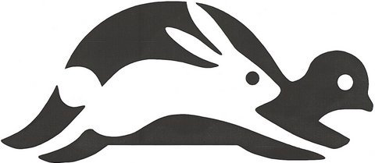

The Tortoise and the Hare

A Hare one day ridiculed the short feet and slow pace of the Tortoise, who replied, laughing: “Though you be swift as the wind, I will beat you in a race.” The Hare, believing her assertion to be simply impossible, agreed to the proposal, and they agreed that the Fox should choose the course and fix the goal. On the day appointed for the race, the two started together. The Tortoise never for a moment stopped, but went on with a slow but steady pace straight to the end of the course. The Hare, lying down by the wayside, fell fast asleep. At last waking up, and moving as fast as he could, he saw the Tortoise had reached the goal.

This season, it’s not about how quickly we achieve our goals; instead, we will focus on slow and steady progression and improvement in our skills, taking the division by surprise!
Slow and Steady Wins the Race!

Don’t forget last season’s Fable Focus, The Four Oxen and the Lion:

A Lion used to prowl about a field in which Four Oxen used to dwell. Many a time he tried to attack them, but whenever he came near they turned their tails to one another, so that whichever way he approached them, he was met by the horns of one of them. At last, however, they fell to fighting among themselves, and each went off to pasture alone in a separate corner of the field. Then the Lion attacked them one by one and soon made an end of all four.

Sticking together is what matters! Playing as a team and working towards a common goal is how we will be successful.

United we stand, divided we fall.

