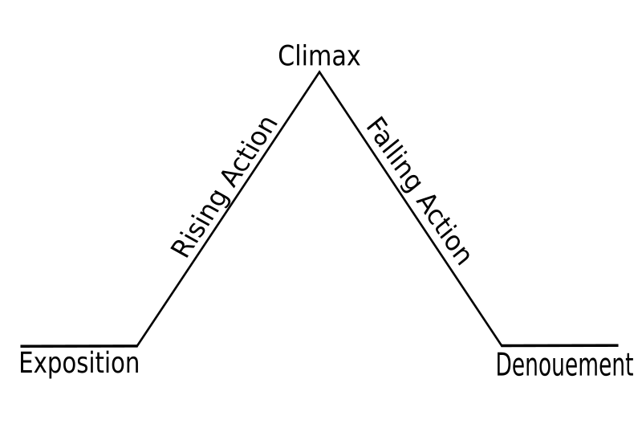

**STUDY GUIDE FOR MIDTERM**

**Freytag’s pyramid of the “SNIPER”**

Setting: Civil War in Ireland

Main Characters: Republican Sniper

Enemy Sniper (no names)

RESOLUTION: The enemy dies and falls off the roof

Denoument: We learn that the enemy is his brother.

-He plays a trick on the enemy: He fakes his own death so that his enemy will leave cover

-The sniper shot his enemy.

When the sniper gets shot in the arm, this is the turning point.

-He shot and killed an informant and an enemy

-The sniper lights up a cigarette and that’s why he gets shot at.

Conflict

Man vs. Man (they are fighting to kill)



When the princess gestures to the door on the right.

RESOLUTION IS UNCLEAR:

If he picks tiger= death

If he picks lady= marriage

Denoument: moral of story/ human nature

-The princess is jealous of the woman who might marry lover

-The princess learns the secret of the doors

-Man goes into arena

Conflict

Man vs. self (the lover has to decide if he should listen to the princess)

Man vs. Nature (if tiger is chosen)

Man vs. society

Setting: Medieval times, King’s arena

Characters: King, Princess and her lover

The man choses the door on the right

**STUDY GUIDE FOR MIDTERM**

**Freytag’s pyramid of the “The Lady or Tiger”**