Name: _________________ “The Cyclops” The Odyssey
What do you think it means when the narrator says that the Cyclops were giants “without a law to bless them…” (line 111)? __________________________________________________________________
Provide a line of text that backs up your opinion: _____________________________________
___________________________________________________________________________________
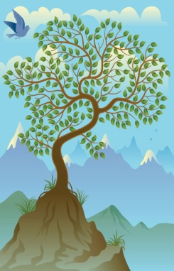
The makeup of the island in the Aegean Sea that they landed on was described as (provide 4 adjectives):
_________________________ ___________________________

_________________________ ___________________________
When the men arrived on the island, they noticed animals grazing on the mountain. Why would Odysseus and his men want to stop at an island that had goats?__________________________________________
What did Ulysses and his 12 best fighters carry with them when they went to explore the island? Provide a line of text as evidence: ___________________________________________________________________
A “kid” is a baby goat. What else was in the cave besides baby goats? _______________________________________________________________________________________
When his men suggested that they steal cheese and let the goats free from their captivity in the Cyclop’s cave, he refused. Why? ____________________________________________________________________
_______________________________________________________________________________________
After the Cyclops asked Odysseus who he and his men were (lines 197-200), Odysseus says lines 214-216. What does he mean? ______________________________________________________________________
Why does he say this? _____________________________________________________________________
What does Odysseus says happened to his ship on page 654? ______________________________________
What was the Cyclops’s response to this? ___________________________________________________
Lines 245-251, Odysseus almost kills the Cyclops. What stopped him? Provide a quote to support: _______________________________________________________________________________________
What did Odysseus and his men make in lines 266-280? What is it for? Predict what will happen: ________
_______________________________________________________________________________________
In lines 297, Odysseus persuades the Cyclops to drink the wine, and the Cyclops agrees, proving
to us that Odysseus is also (adjective) _________________.
Who is “Nohbdy” (Nobody)?____________________

What did Odysseus and his men do to the Cyclops when he was drunk and asleep?
___________________________________________________________________
In line 352, we learn the Cyclop’s name. What is it? _________________________
Why didn’t the Cyclop’s friends come to help him? ______________ _______________________________________________________________________________________
How did Odysseus and his men escape from the cave? _______________________________________________________________________________________
_______________________________________________________________________________________
When the crew is leaving, Odysseus taunts (or baits) the Cyclops. How do his men react? _______________________________________________________________________________________
What does the Cyclops do in response to Odysseus’s taunting? See lines 484-494: ____________________
_______________________________________________________________________________________
What do you predict will happen next to Odysseus and his men? ___________________________________
_______________________________________________________________________________________

