Counterclaims:

EXAMPLE COUNTERCLAIM TEXT PARAGRAPH:
Although some people claim that American Dad is the best show on TV, How I Met Your Mother is a better show due to its comedy (T). American Dad has good comedic timing, but “How I Met Your Mother has the most talented actors out there” as stated in UsWeekly (E). The main actors in How I Met Your Mother are the highest paid, most talented actors in comedy (X). Due to this, the show is widely regarded as the best comedy ever (T).

The GREATEST show that has ever been on TV is How I Met Your Mother.
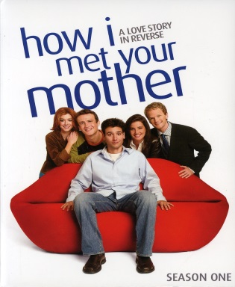
Agree or disagree? Why? RESPOND BELOW:

Crafting a COUNTERCLAIM:
1) SEEM to agree with my opinion
2) but at the end of the sentence, explain why I’m wrong
3) Then give evidence to explain why your TV show is better.

